EXPERIMENT 2: VACUUM CLEANER PROBLEM

Aim: To implement a simple Vacuum Cleaner Agent that cleans all dirty rooms.

Objectives:
- To understand the working of a Vacuum Cleaner Agent.
- To clean dirty rooms using simple AI rules.
- To demonstrate a simple intelligent agent.

Algorithm:
- Start.
- Read the status of Room A and Room B.
- If the current room is dirty, clean it.
- Move to the other room.
- If the room is dirty, clean it.
- Stop when both rooms are clean.

Flow Chart
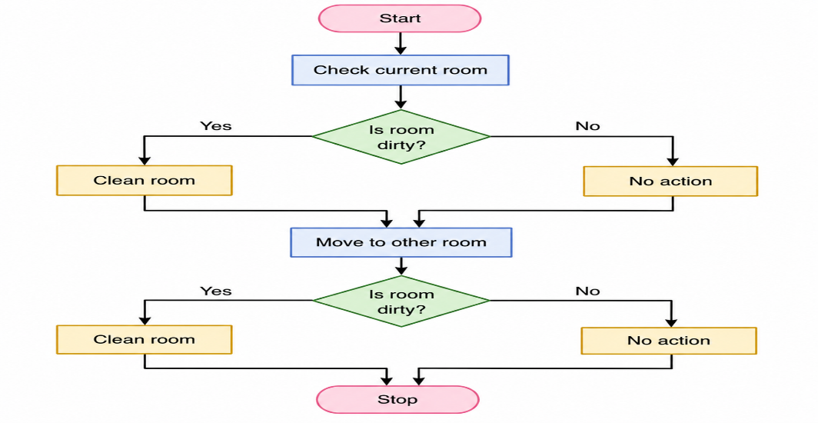
Source Code:

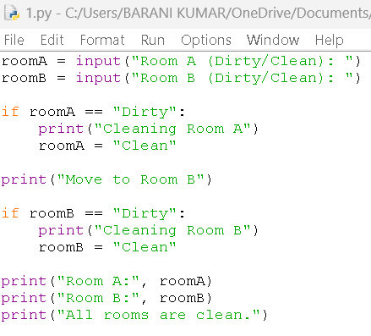
OUTPUT:
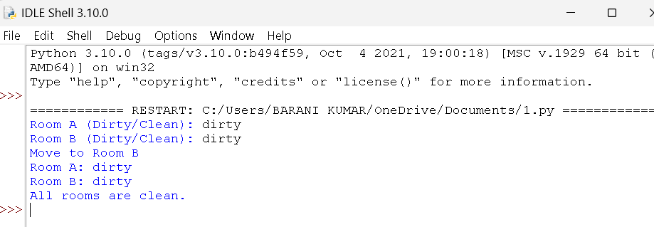

Result:
The Vacuum Cleaner Agent successfully cleaned all the dirty rooms using simple AI rules.

